Expected Number of Beneficiaries, and Job Opportunities for the 4th Quarter, 2002 According to Sectors

Sector | Beneficiaries |  | Job Opportunities
 | Direct | Indirect | Temporary | Permanent
Education | 21681 | 5273 | 208679 | 68
Health | 2391 | 0 | 2678 | 0
Water | 14112 | 790 | 41726 | 4
Environment | 94735 | 84500 | 34325 | 512
Cultural Heritage | 0 | 0 | 1830 | 0
Roads | 0 | 0 | 11667 | 0
Micro Enterprises Dev. | 65 | 260 | 31 | 140
Special Needs Grs. | 511 | 350 | 11311 | 39
Training | 1031 | 2084 | 2014 | 4
Organizational Sup. | 244 | 0 | 283 | 15
Total | 134770 | 93257 | 314544 | 782

SFD Cumulative Investments and Disbursements

As of 31/12/2002 According to Governorates

 | Governorates | No. of Projects | Commitments ($) | Disbursement ($)
 | Sana’a Capital | 265 | 21,762,602 | 11,996,662
 | Sanaa | 246 | 19,594,226 | 11,445,067
 | Aden | 268 | 17,777,672 | 10,545,924
 | Taiz | 257 | 15,916,398 | 7,760,525
 | Hodiedah | 206 | 13,680,168 | 8,237,232
 | Lahj | 209 | 13,500,067 | 7,206,878
 | Ibb | 191 | 12,075,591 | 7,616,440
 | Abian | 173 | 11,886,636 | 6,860,562
 | Dhamar | 167 | 11,035,322 | 5,572,318
 | Shabwah | 119 | 9,620,427 | 4,880,852
 | Hajjah | 97 | 9,008,237 | 5,484,464
 | Baidhaa | 79 | 6,947,688 | 3,407,896
 | Hadhramout | 96 | 6,316,585 | 3,780,181
 | Saadah | 75 | 5,327,648 | 3,488,150
 | Mahweet | 76 | 4,748,130 | 2,481,903
 | Maharah | 71 | 4,238,806 | 2,591,599
 | Maarib | 50 | 3,405,285 | 1,913,301
 | Al-Jawf | 37 | 2,490,904 | 1,382,954
 | Amran | 40 | 2,380,811 | 1,853,778
 | Al-Dhala’a | 40 | 2,270,550 | 1,336,809
 | More than one governorates | 80 | 1,735,713 | 1,266,444
 | Total | 2842 | 195,719,466 | 111,109,939

SFD Cumulative Investments, Disbursements as of 31/12/2002 According to Sectors
Sector | No. of projects | Commitments ($) | Disbursements  ($)
Education | 1409 | 103,650,877 | 59,031,475
Health | 276 | 16,302,332 | 11,065,104
Water | 526 | 32,266,878 | 18,878,291
Environment | 74 | 9,258,760 | 4,706,861
Cultural Heritage | 29 | 4,582,475 | 1,693,290
Roads | 101 | 11,239,737 | 4,878,094
Micro Enterprises Dev. | 38 | 3,903,207 | 2,529,698
Special Needs Groups | 126 | 9,562,349 | 5,306,367
Integrated Interventions | 17 | 1,037,513 | 323,493
Training | 111 | 1,519,414 | 1,079,101
Organizational Support | 135 | 2,395,929 | 1,618,161
Total | 2842 | 195,719,466 | 111,109,939
Expected Number of Beneficiaries, and Job Opportunities as of 31/12/2002 According to Sectors
Sector | Beneficiaries |  | Job Opportunities
 | Direct | Indirect | Temporary | Permanent
Education | 938,705 | 141,567 | 4,297,488 | 10,433
Health | 1,235,220 | 197,543 | 534,762 | 2,733
Water | 1,432,166 | 126,874 | 1,463,339 | 640
Environment | 1,051,760 | 144,650 | 288,642 | 1,409
Cultural Heritage | 131,225 | 42,560 | 221,391 | 36
Roads | 890,592 | 511,887 | 767,153 | 22,713
Micro Enterprises Dev. | 23,406 | 129,057 | 7,540 | 383
Special Needs Grs. | 70,612 | 61,761 | 288,165 | 784
Integrated Interventions | 48,203 | 113,223 | 41,890 | 36
Training | 9,257 | 60,212 | 24,922 | 268
Organizational Sup. | 79,176 | 6,679 | 43,306 | 150
Total | 5,910,322 | 1,536,013 | 7,978,591 | 39,585

Completed Projects as of 31/12/ 2002
Sector | No. of Projects | Investments ($)* | Disbursements ($)*
Education | 713 | 39,525,143 | 36,756,650
Health | 145 | 7,362,331 | 6,371,749
Water | 229 | 13,683,283 | 13,273,700
Environment | 28 | 3,199,976 | 3,147,390
Cultural Heritage | 3 | 483,540 | 393,097
Roads | 18 | 1,840,915 | 2,074,109
Micro Enterprises Dev. | 18 | 678,598 | 511,182
Special Need Groups | 18 | 1,348,665 | 1,125,281
Integrated Interventions | 5 | 110,813 | 93,658
Training | 80 | 986,011 | 856,985
Organizational Support | 67 | 1,013,476 | 983,492
Total | 1,324 | 70,232,750 | 65,587,294
*Completed but not closed projects and their final costs are subject to change

In July 2002, the Social Fund submitted to its Board of Directors the 2003 budget at an amount of US$83, hoping that additional resources will be allocated to meet its resources shortage.

However, all efforts made by the SFD did not raise the entire amount needed to finance the 2003 activities. Therefore, SFD was required to significantly reduce the draft budget from around US$83 million to approximately US$43 million.

In fact the severe shortage in resources had already begun negatively affecting SFD operations during the second half of 2002, with commitment dropping to around US$17 million, from approximately US$43 million during the first half of the year.

During the third quarter of the year, the Fund prepared an outlines for a third phase of its activities. The SFD Board endorsed the Phase III proposal at the cost of US$400 million and empowered relevant authorities to take necessary measures to secure the required funding from various donors. Accordingly the Ministry of Planning and Development has started communication with various donors.

The SFD is hoping to raise the required funds in order to start a third phase of its activities at the beginning of 2004. This resuming its activities in full capacity and contributing through its mandate in poverty reducation and as one of the main programs in the Social Safety Net.

Edition No. 20, Octber-Decmber 2002

Social Fund for Development

30 Al-Kuds ST. P.O. Box 15485

Sana’a, Republic of Yemen

Tel.: (967-1) 240417, Fax: (967-1) 243173

E-Mail: sfd@sfd-yemen.org

www.sfd-yemen.org

Highlights

Social Fund at the Paris Consultative Group Meeting: During the convention of the Consultative Group Meeting (Paris, October 16 – 17), Mr. Abdulkarim Al-Arhabi, Managing Director of the Social Fund for Development, met with representatives of donors to SFD. Donors expressed their willingness to carry out a joint mid-term review process of the SFD Phase II (2001 – 2003), in preparation for initiating Phase III in 2004.

Initiation of Training Program for Local Councils: This quarter witnessed the commencement of the preparation phase for conducting training programs designed to upgrade the capacities of 332 local councils (LC’s) in the various governorates and districts throughout the Republic. In this phase, two training courses were held for consultants on assessing LCs training needs to address training requirements during 2003.

Action Plan for 2003:Under the chairmanship of Mr. Abdulkareem Al-Arhabi, the Managing Director of the Social Fund, a meeting was held at the SFD premises in Sana’a November 16 – 18 attended by leadership of units and the managers of branch offices. The meeting focused primarily on three issues: targeting, innovation and capacity building of local communities, government institutions and NGO’s. Additional issues addressed included efficiency, cost-effectiveness, technical solutions and accountability. Following an extensive discussion on targeting, it was decided that branch offices and the Units should prioritize projects in 2003 that serve impoverished districts where poverty indicators (PI) exceed 60%, followed by districts where PI range between 50 – 59 %. Should additional donor funds become available during 2003, extensions shall be considered in additional geographic areas.

SFD 2003 Impact Evaluation. Preparation has commenced to launch the SFD impact evaluation survey. This survey will assess 4000 households and 200 sub-projects across the country. The survey will assess post-project impact, as well as collect baseline data. In the post-project survey, 2000 households will be visited to measure the impact of completed SFD interventions. The latter will survey additional 2000 households that will be used in SFD impact evaluation to be carried out in 2006. Completed preparations for the impact evaluation include defining the methodology, designing survey forms and piloting.

Fog Water Collection: A pilot project in fog water collection was signed. This pilot project aims to study the feasibility of generating drinking water in some of Hajja sub-districts collecting generated by fog, a common weather phenomenon in some of Yemen’s easter nes carpmen usually lasting from December to March .

1

The Second Meeting of the SFD Board of Directors in 2002

Under the chairmanship of H.E. Mr. Abdulkader Ba-Jammal, the Prime Minister and Chairman of the SFD Board of Directors, the board held its second meeting for the year on July 27, 2002. The two primary agenda items addressed and approved were the 2003 draft budget and appointing an independent external auditor to review SFD's financial records. Also discussed at the meeting was the issue of securing additional financial resources for the Social Fund's activities.
One of
the fog collectors
Third Meeting of the Board of Directors

The SFD Board of Directors held its third meeting for the year 2002 on Monday November 4, 2002. H.E. Mr. Abdulkader Ba-Jammal, Prime Minister and Chairman of the Board, chaired
the meeting. The main issues discussed were:
- SFD funding needs for Phase III of its operations(2004 –2008).
2.Report on SFD operations for the period January – September 2002.
The Board of Directors discussed projections for Phase III anticipated to include 4,778 sub-projects distributed in 10 sectors at an estimated total cost of US$400 Million. The SFD Board endorsed the Phase III plan and empowered relevant authorities to take necessary measures to secure the required funding from various donors.

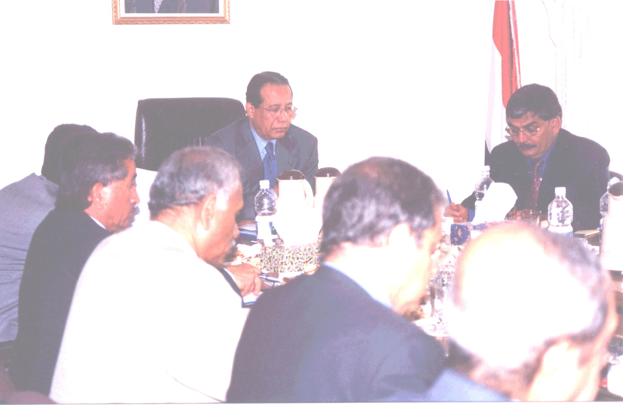
Prime Minister and Chairman of the Board, chaired
the meeting
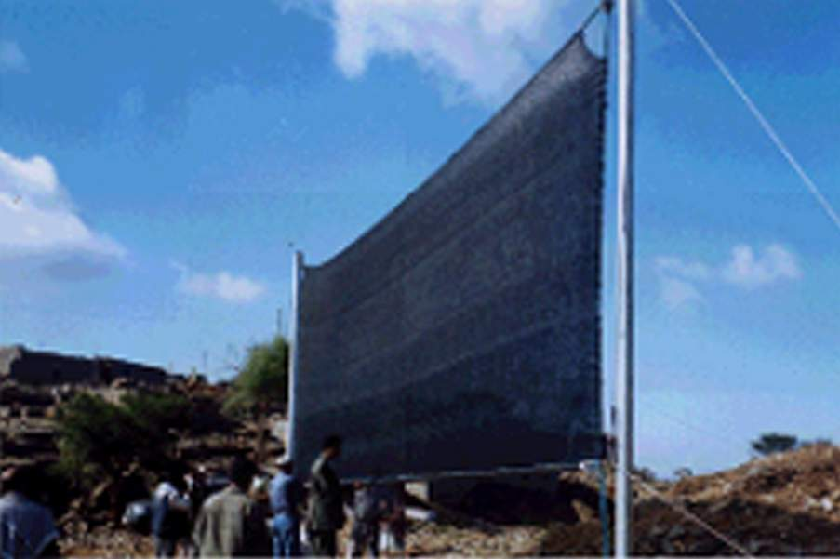
Social Fund for Development Newsletter- Edition No. 20 2 2
- October 19th to the 27th a Workshop on Preparing a National Strategy for the National Union of Yemeni Disabled Associations was held. This workshop occurred within the framework of Phase II activities providing organizational support for union.
- October 8 – 17 a course on Braille techniques was held in Zabid of al-Hodeidah for 13 teachers from Zabid Training Center, as part of an education project for SNGs.
- A contract was signed for a total of US $ 59,000 to finance an inclusive education.
- The first draft of the national strategy of “Children in Difficult Circumstances” was completed. A Steering Committee is formed, comprising representatives of the Higher Council of Motherhood and Childhood and several government and donor agencies. The first meeting of the Steering Committee is expected to be held in February 2003.

Integrated Interventions

- Field visits for the trainers in health and environmental awareness targeting Local Development Committees in the areas of integrated interventions has commenced to asses the situation on the ground and come up with practical ideas and lessons to be incorporated in the program.
- A training course was organized on adult education. Sixteen female teachers from Al-Mihsama villages, Hanadh, Ambesty, Ahwar District, Abyan Governorate participated in the course.
- The Integrated Intervention Officer attended a training course in Lebanon on “Enhancing Educational Research in Popular Education”.
Small and Micro-enterprise Development Unit

Training Course on Management and Supervision. Twenty-eight representatives of the sponsoring agencies and programs, including 16 females, participated in the training course that was held in Sana’a from October 19 – 24 . The course (only the second of its kind), addressed issues of management and supervision in the sector of economic empowerment .

First Micro-Finance Workshop. On October 7th and 8th the SMED Unit organized a workshop for micro-finance throughout the country. Representatives of the SFD Micro-finance Programs also participated in the workshop. This workshop was designed to share and collect information of various programs in this field, exchange experience of those involved in the sector and address specific challenges and issues. Participants shared their challenges and experiences and recommended that similar workshops be organized in the future.

Business Department Services Study. During this quarter a consultant conducted and completed an assessment study of SFD interventions in providing non-financial services to small and micro-enterprises. The consultant reinforced the importance of such services, however the absence of local expertise in this field. This study recommended that SFD, in cooperation with different institutions, finance further activities and pilot projects designed to provide non-financial services for entrepreneurs of small and micro enterprises.

Advanced Training Course for the Accountants of the Micro-Finance Programs. From September 28th to October 5th, the first training course in advanced accounting was held in Sana’a for accountants of small-enterprise programs. Seventeen trainees from 12 programs participated in the course that aimed at enhancing the professional skills of participants and enabling them to improve their job performance.

- Training Activities:
Training Unit
During the 4th quarter 9 projects were contracted with a total estimated cost of US$182,837, including the following unit activities:
Training Sector
Four projects with the following objectives:
- Capacity Building for Local Councils (LC). (Two projects). The first one was implemented in Amran City and focused on developing “zakat” (alms) revenues by systematizing assessment and collection within the LCs. The second project consist of two training courses that were held in Sana’a for consultants from the different governorates in assessing capacity building needs of the LCs.
- Expanding Consultant and Contractor Capabilities: A project for training consultants and contractors in the governorate of Al-Hodeidah, aiming at introducing SFD polices, procedure standards and various types of project interventions.
- Support to Local Organizations. A project to support training activities for a charitable society in Al-Mashawela/ Al-Waze’iya district in Taiz governorate.

Organizational Support Sector
Five projects are currently under implementation. They include the following:
- Organizational support for NGO’s (3 projects) with training of trainers and providing essential equipment. The support is targeting two charitable associations in Hadhramaut governorate and one in Aden governorate
- Organizational support for Government Organizations (one project). This project targets the Military Museum in Aden and comprises establishing a database for the Museum, providing equipment, networking and training of Museum staff in system operation and maintenance. Additionally, the project will inuse software components already installed in the National museum.
- Program for Impact Evaluation of the SFD projects (one project). The project aims at training personnel to conduct field surveys.
Other Activities:
- Preparation activities to follow up SFD intervention impact in beekeepers training programs. This activity included the preparation survey forms and piloting.
- Follow up on the implementation of a World Bank’s grant ($182,250) that is executed through the SFD and aiming to enhance the capacities of the relevant bodies of the Ministry of Social Affairs & Labor concerning civil society sector, as well as civil society organizations on understanding and implementing of Yemen NOGs Law.
- Conduct a preliminary study for the Ministry of Technical Education & Vocational Training and the Agricultural Co-operative Federation. The study aims to identify the needs of these two agencies with respect to training programs and other relevant requirements.
- A Unit’s staff member participated in a training-of-trainers course on “Gender”, which was held in Beirut.
- Support the Local Council in Manakha district (Haraz) to open a social training center for women, with a joint funding of both the SFD and the LC.

Social Protection Unit
The Social Protection Unit (SPU) participated in the Arab conference “The child and the City” convened in Amman, Jordan from December 11 – 13.
Health
- Six projects were approved with an estimated cost of US $ 1.2 million.
- The Unit participated in selecting 193 male and female students (from Mareb governorate and Kholan district, Sana’a governorate) to study at the Higher Institute for Health Sciences. This course is being financed by the US Embassy and implemented by SFD.

Special-Needs Groups (SNG’s)
Seven projects, with an estimated cost of US $ 0.9 million, were contracted with selected community associations, government entities and other bodies working with SNGs. Training activities were organized for the management of some associations including computer, accounting and administration.

Infrastructure Unit
Education
SFD and three ministries were delegated by the Council of Ministers to implement Resolution No. 262 (2002) to enhance information technology education at selected secondary and post-secondary institutions. SFD (through its Training Unit) will provide essential furnishings, computers and electrical systems. The Fund will also survey computer labs in 19 secondary schools distributed in five governorates, following the assessment of preparedness of secondary schools nominated to participate in the program.
- Following the completion of training of the community contracting team, field implementation began during this quarter. Preliminary indicators demonstrate a favorable response and reaction, as well as an effective implementation.

Cultural Heritage
- An agreement was signed with the French Embassy to delegate a specialist to support the SFD activities in the cultural heritage sector. According to the agreement, this expert, with extensive expertise in Yemen, will join the Fund’s team in 2003.
- Al-Hodaidah branch office represented the Social Fund in the first scientific conference on Zabid City, which was held in Al-Hodeidah on December 14 - 17.

Roads
As part of SFD’s on-going project evaluation and monitoring , two World Bank experts visited on-going road projects. The assessment of these experts praised local community participation in implementation, particularly in the road sector projects. Their assessment recommended documenting SFD`s experience in rural road construction, as well as the projects implemented directly by communities, in order to disseminate lessons learned from this experience.

Water & Environment Unit
Water
During this quarter 20 projects were approved, thus bringing the cumulative total projects to 526. The Fund’s commitments in this sector during the quarter were US $ 0.9 million, with total commitment being US $ 32.3 million. The total disbursed amount was US $ 18.9 million by the end of this period. Activities in this sector included:
- A workshop to improve direct implementation (community contracting) mechanism was held from November 2 – 4 . Attendees included 33 participants active in direct implementation projects, including 15 engineer consultants , five SFD project officers, six accounting consultants, two engineers from the Agricultural & Fishery Production Enhancement Fund and five representatives of beneficiary communities.
- Publication of the “Health Awareness Manual” for rainwater harvesting projects.
- An agreement was signed with the International Social Services Association to finance the pilot project for fog water collection in Hajja governorate.

Environment
Three projects were approved during this quarter; thus, as of the end of the quarter, the cumulative number of projects reached 74, with 4th quarter commitments totaling US $ 1 million, total commitments of US $ 9.5 million and total disbursements of US $ 4 Million.
- A workshop was held on medical waste disposal on December 31 attended by managers of nearly 50 hospitals and medical clinics. The workshop discussion focused on ideas for the disposal of hazardous medical waste and proceedings contributed to the efforts of the team of consultation assigned to conduct a project study.

Social Fund for Development Newsletter- Edition No. 20 3 3 3 3
The following table shows portfolios of SMED programs as of 31/12/2002

Program | cumulative  No. of Borrowers*  No. of Savers*  Loan Amounts  (million YR) |  |  | Out-standing portfolio*
Program | No. of Borrowers | No. of Savers | Loan Amounts* | Out-standing portfolio*
Hodeidah Micro Credit | 5,048 | 0 | 230.9 | 45.4
Hais Saving & Credit | 1,345 | 1,500 | 40.3 | 7.5
Al-Maraweah IG | 3,306 | 0 | 150 | 9.2
Al-Odain IG | 334 | 0 | 17.9 | 2.7
Wadi Hadhramout | 306 | 0 | 23,2 | 10.9
Dar Sad Saving Credit | 467 | 687 | 14.8 | 5.7
Muala Saving & Credit | 307 | 342 | 10.3 | 4
Sana’a Micro-finance | 279 | 0 | 10.8 | 6
Ibb Saving & Credit | 120 | 456 | 2.6 | 2
Taiz Saving & Credit | 103 | 534 | 1.7 | 1
Dhamar Saving & Credit | 278 | 579 | 6,2 | 5
Other Programs | 3,255 | 475 | 91.4 | N.A
Total | 15,148 | 4,573 | 690.6 | 100
N.P Not Applicable
*. Amounts are In YR Millions

Achievements of the Fourth Quarter of 2002

The SFD has contracted 112 Projects during the fourth quarter of 2002, with a total investment of about US$7.4 million

Investments by Sector, 4th Quarter, 2002

Investments by Governorate 4th Quarter, 2002

Governorate | No. of projects | Commitments  ($) | %
Sana’a Capital | 12 | 118,693 | 2%
Sana’a | 10 | 556,954 | 7%
Aden | 4 | 285,500 | 4%
Taiz | 12 | 1,068,952 | 14%
Hodeidah | 7 | 770,920 | 10%
Lahj | 4 | 194,980 | 3%
Ibb | 5 | 285,155 | 4%
Abian | 2 | 204,310 | 3%
Dhamar | 4 | 305,776 | 4%
Shabwah | 2 | 92,150 | 1%
Hajjah | 12 | 764,285 | 10%
Baidha | 9 | 680,145 | 9%
Hadhramout | 2 | 106,467 | 1%
Saadah | 2 | 124,540 | 2%
Mahweet | 2 | 463,391 | 6%
Al-Jawf | 2 | 128.858 | 2%
Maarib | 1 | 69,709 | 1%
Amran | 17 | 1,110,142 | 15%
More than one | 3 | 100,303 | 1%
Total | 112 | 7,431,230 | 100%

